1. Explain the history of android operating system.[10]
2. Explain the life cycle of android activity along with suitable diagram.[10]
3. What do you understand by Kernel? Write down the pros and cons of android operating system.[2+8]
4. What is the use of Intent? Write a sample program to send data from one activity to another.[2+8]
5. Explain the steps of referencing a view into java class? Explain with suitable example.[2+8]
6. What do understand by View? Explain following [2+8]
7. Button and TextView
8. EditText and Progress Bar
9. Explain linear layout and relative layout. Design the following layout using relative layout.[2+8]

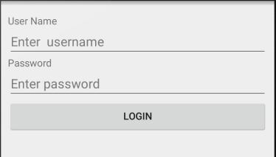

1. What do you understand by DialogBox? Write sample program.[2+8]
2. Design the given layout and toast all the information when a submit button is clicked.[10]

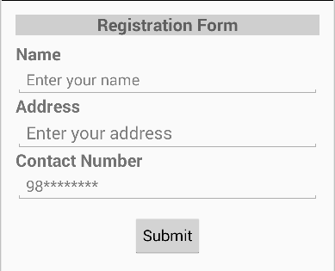

1. Write short notes on (any two) [2X5]
2. Toast, Log and Views
3. Implementations of animation
4. Button Listener